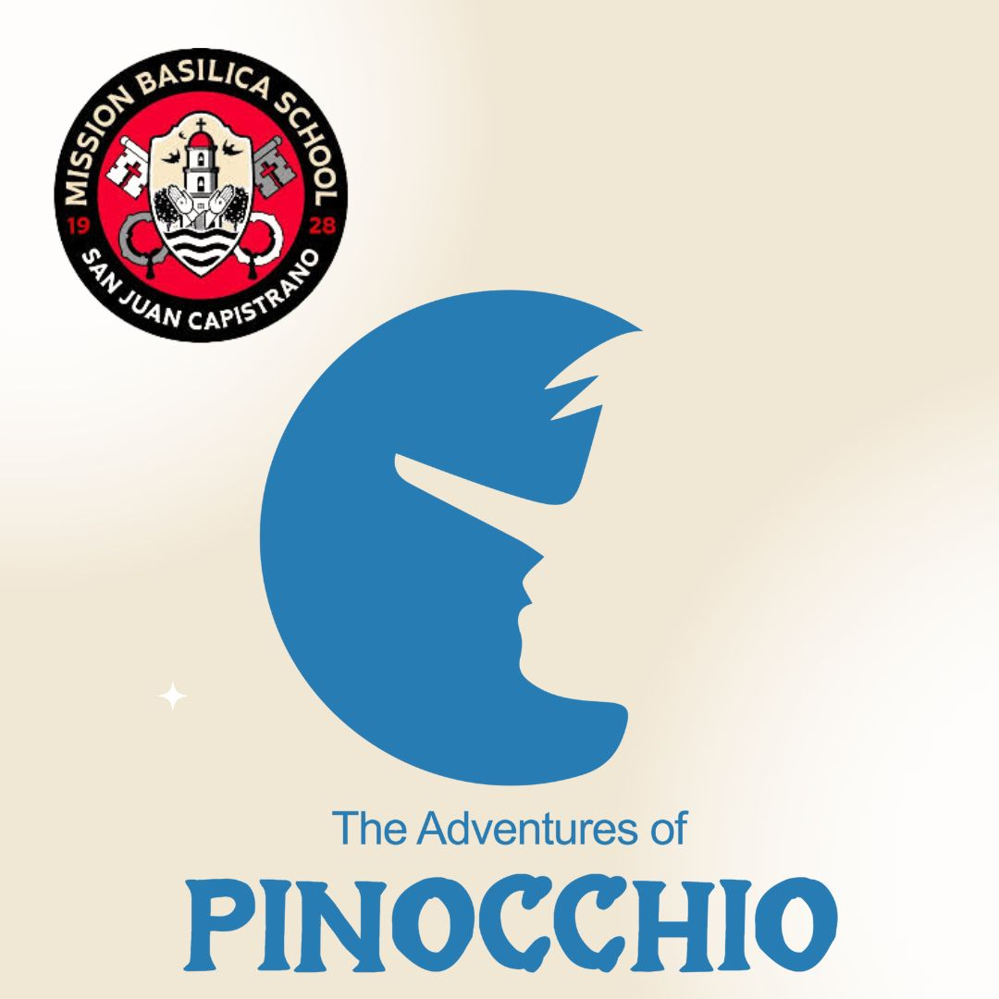
Costume Requirements

Rachael Gafner
Director& CKP Production Manager
Rachael@creativekidsplayhouse.com

PINOCCHIO

REQUIRED FROM HOME:
- SIMON – Black long sleeve shirt, Black pants, and Black socks
- GEPETTO – White tank top, Black pants, and Black socks
- ETHEL – White tank top, dance shorts, and White tights
- JIMINIE – White button down (short sleeve), Black pants, and Green socks
- CATY CAT & FOXY FOX – Black tank top and Black leggings
- BOYS: White tank top, Basketball Shorts, and White socks
- GIRLS: Tank top (any color), dance shorts (any color), if actors want to wear socks, please have them be white
- ALL ACTORS: Black Jazz or Ballet Shoes

HAIR:
- ETHEL – Hair in bun
- GIRLS – Hair can be in either down, in low pigtails, or braids
- BOYS – Brush and style

MAKEUP REQUIREMENTS FOR ALL ACTORS:
- Powder (If you have a lighter complexion, please use bronzer), Pink Lipstick (slightly brighter than usual, but not neon! Please also stay away from any reds! Blush, Eyeshadow (browns or greys, just to bring out the eyes), Eyeliner, Mascara.

